Modeling & Interpreting Data
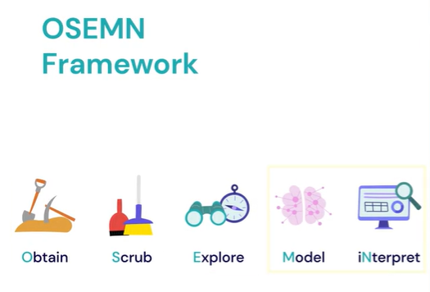

Modeling and Interpreting in the AWESOME Framework
In this lesson, we reviewed the final two stages of the AWESOME framework — Modeling and Interpreting — which come after Obtaining, Scrubbing, and Exploring data.
- Modeling Phase
  - This stage involves using existing data to make predictions or draw insights about future or unseen data.
  - The goal is to extend what we already know by building models that help uncover deeper patterns and relationships.
  - As data analysts, we often use simplified modeling tools in Python to test hypotheses and explore possible outcomes.
- Interpreting Phase
  - This phase focuses on turning analytical results into actionable insights.
  - We use our understanding of the data and model outputs to tell a clear, meaningful story.
  - This often includes creating explanatory visualizations and crafting recommendations for stakeholders.
  - The outcome is a digestible report or presentation summarizing findings and next steps.
Together, these phases bring the entire data analysis process full circle — from data collection and cleaning to generating insights and informing decision-making.
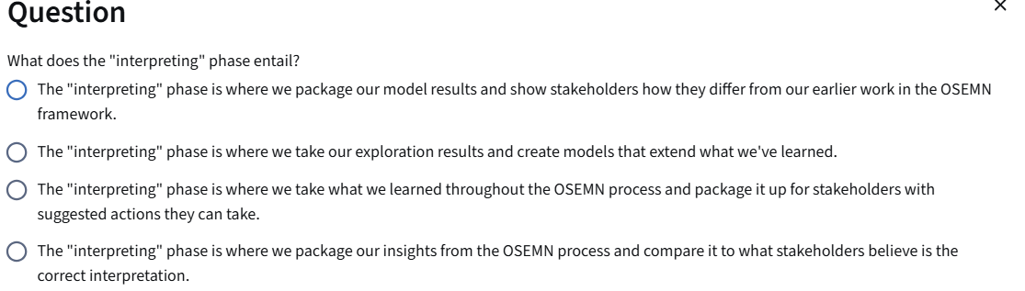
During this phase, we want to package up what we learned so it can be understood by the stakeholders. We usually will also suggest a set of actions to take related to our insights.

✅ Summary (concise)
You have completed the first three phases of the A.W.E.S.O.M.E. data analysis framework — Obtain, Scrub, and Explore — using Python. The next two phases are:
- Modeling: Use what you learned from the data to make predictions or extend insights beyond the given dataset (extrapolation).
- Interpreting: Combine everything — data understanding, model results, and visualizations — to tell a clear story and give actionable recommendations to stakeholders.

📄 ONE-PAGE EXAM SHEET — Modeling (A.W.E.S.O.M.E. Framework)
(Python Data Analyst Edition — concise, high-value review)

✅ Where Modeling Fits
- Phase after Explore
- Use cleaned + understood data to extend insights and support decisions.

🚀 What Is Modeling?
Using existing data to make predictions, classify new data, or discover patterns.
Modeling ≠ only prediction — it includes forecasting, classification, and clustering.

🔧 Types of Models
Model Type | Goal | What It Does | Example Use Case
Regression | Predict numeric value | Predict continuous outcomes | Forecast sales next week
Time Series Forecasting (special regression) | Predict value over time | Uses dates/time patterns | Predict future revenue based on daily sales
Classification | Assign categories | Requires known labels | Decide what coupon to offer a customer
Clustering | Group similar data | No labels needed (unsupervised) | Segment customers into personas

🧠 Key Ideas to Remember
- Modeling converts data into future-looking insights.
- Simple models → fewer assumptions (e.g., "next week sales = last week sales").
- Complex models → include multiple factors (seasonality, holidays, marketing campaigns).

⚠️ Modeling Pitfalls
Risk | What It Means | Why It Matters
Data Bias | Bad or incomplete data → bad predictions | Garbage in = garbage out
Model Rot / Data Drift | Model becomes inaccurate as new data changes | Must update models regularly
Wrong Use Case | Using a model for the wrong question | Subscription predictor ≠ coupon predictor
No model is perfect. Models guide decisions — they don’t replace them.

🛠️ Python Mini-Reference (pseudocode-like)
# Regression (e.g., linear model)
from sklearn.linear_model import LinearRegression
model = LinearRegression().fit(X_train, y_train)
predictions = model.predict(X_test)

# Classification (e.g., decision tree)
from sklearn.tree import DecisionTreeClassifier
model = DecisionTreeClassifier().fit(X, y)
labels = model.predict(new_data)

# Clustering (e.g., k-means)
from sklearn.cluster import KMeans
kmeans = KMeans(n_clusters=3).fit(data)
clusters = kmeans.labels_
(You don’t need detailed syntax for the exam—know what each type does.)

⭐ What To Say in an Interview / Written Exam
“Modeling helps extend insights beyond what is already known.
I choose the model type based on the business goal: regression for predicting numbers, classification for labeling, clustering for discovering groups.”

✅ Final Checklist
- Know when to use each model type.
- Keep in mind risks (bias, drift, misuse).
- Focus on insight and value, not complexity.

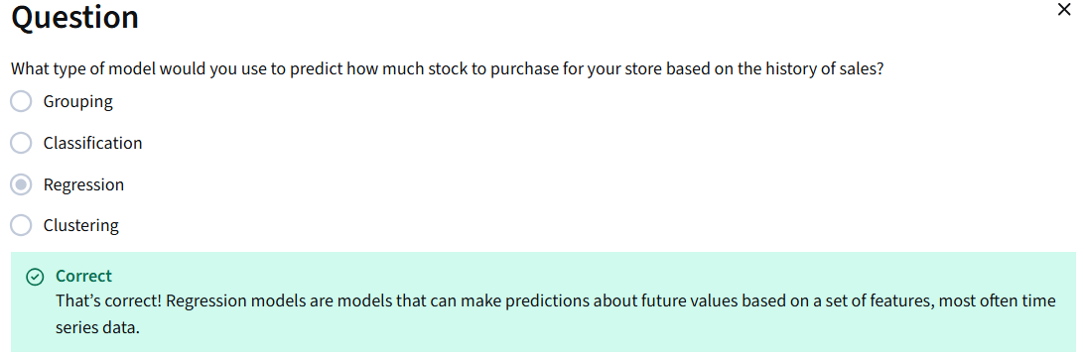

✅ Summary of the Video (Modeling with the Special Tool)
This lesson introduces practical modeling in Python using a simplified, course-specific tool called the Pocket Data Scientist’s Friendly Modeler (a wrapper around Scikit-Learn). It allows you to try modeling without needing deep machine-learning knowledge.

🔍 Key Concepts

1. Modeling in Python
- Uses past data to make predictions or discover patterns.
- Typically done with libraries like Scikit-Learn, which enable machine learning models such as:
  - Regression (predict numbers)
  - Classification (predict categories)
  - Clustering (group similar data)

🧩 Models Demonstrated
Model Type | What it does | Target feature? | Purpose in the video
Regression | Predicts a numeric value | ✅ Yes (Amount Spent) | Predict how much money a customer will spend
Classification | Assigns a category/class | ✅ Yes (Customer Group A/B/C) | Predict which customer group a person belongs to
Clustering | Groups similar data | ❌ No target | Automatically segments customers into behavior-based clusters

📊 What the Special Tool Does
Instead of manually building models (like Scikit-Learn), the Friendly Modeler:
- Accepts a DataFrame and description.
- Builds the model automatically behind the scenes.
- Shows useful visualizations and performance metrics.

🧪 Regression Outputs
- Produces predictions for each row.
- Displays Mean Absolute Error (MAE) → measures how far predictions are from the real value (lower = better).
- Scatter + histogram show model accuracy and error patterns.

🧪 Classification Outputs
- Gives a model score (accuracy from 0–1).
- Shows:
  - Left chart → correct labels in real data
  - Right chart → misclassified points (colored by wrong prediction)

🧪 Clustering Outputs
- No target feature needed.
- Model finds natural groups of customers based on their behavior.
- Output includes:
  - Features used
  - Number of clusters
  - Visualized clusters (colored based on assigned group)

⭐ Insights from the Lesson
- Modeling tools learn patterns from the data (training/fitting).
- Predictions on new, unseen data are called inference.
- Models are rarely perfect — expect some error.
- Good modeling requires:
  - Clean data
  - Clear goals
  - Awareness of model limitations

📌 Exam Cheat Sheet (1-page quick recap)
Term | Definition / Importance
Regression Model | Predicts numeric values. E.g., projected spending.
Classification Model | Predicts categories (labels). E.g., customer group A/B/C.
Clustering Model | Groups similar data without knowing labels. E.g., customer segments.
Training / Fitting | Model learns from the data.
Inference | Model makes predictions on new data.
MAE (Mean Absolute Error) | Measures prediction error in regression.
Accuracy Score | % of correct predictions (classification).
Visualization | Helps evaluate performance & understand model behavior.

✅ One-Page Exam Cheat Sheet — Modeling (Regression, Classification, Clustering)
Role: Data Analyst using Python (pandas, seaborn, sklearn-like workflow)
Topic | What it Means (simple) | Why We Use It | Python Pattern (generic example)
Modeling (in A.W.E.S.O.M.E framework) | Extending insights beyond the given data — predicting or grouping new unseen data | Helps estimate future outcomes, segment customers, guide decisions | No code — concept step before choosing specific model type
Regression | Predict numeric value (target) from features | Forecasting (e.g., revenue, spend, price) | import sklearn.linear_model as lm  model = lm.LinearRegression() model.fit(X, y)  preds = model.predict(X)
Target Feature | Column you want to predict (y) | Defines model objective | y = df["AmountSpent"]
Features | Input variables used to predict (X) | Used to find patterns influencing target | X = df[["DaysMember", "AvgItems", "Device"]]
Fitting / Training | Model learns relationship from existing data | Creates the mapping X ➜ y | model.fit(X, y)
Inference / Predicting | Using the fitted model on new/unseen data | Predict impact or future values | model.predict(new_data)
Evaluation — Regression | Measures how far predictions are from actual values | Validate accuracy | from sklearn.metrics  import mean_absolute_error  mae = mean_absolute_error(y, preds)
MAE (Mean Absolute Error) | Avg. error size (lower = better) | Measures correctness of prediction | Output: MAE = 450.2
Classification | Predict category/class (A/B/C, yes/no…) | Identify customer type, churn, fraud, etc. | from sklearn.tree import DecisionTreeClassifier  model = DecisionTreeClassifier() model.fit(X, y_class)  preds = model.predict(X)
Accuracy Score | % of correct predictions (1 = perfect) | Quick performance metric for classification | from sklearn.metrics import accuracy_score  accuracy = accuracy_score(y_class, preds)
Visualization (classification errors) | Shows where prediction was correct/incorrect | Helps identify misclassified segments | sns.scatterplot(data=df, x="AvgItems", y="AmountSpent", hue=preds)
Clustering | Model groups similar data automatically (no target) | Customer segmentation | from sklearn.cluster import KMeans model = KMeans(n_clusters=3) labels = model.fit_predict(X) df["Cluster"] = labels
Cluster Labels | Group numbers assigned by model | Used to understand behavior of segments | df.groupby("Cluster").mean()

Mini Workflow (Remember this flow!)
# 1. Obtain / Scrub / Explore (done before modeling)
df = pd.read_csv("data.csv")

# 2. Select features & target
X = df[["DaysMember", "AvgItems", "AmountSpent"]]
y = df["AmountSpent"] # for regression
y_class = df["CustomerGroup"] # for classification

# 3. Fit model
model.fit(X, y)

# 4. Predict (new or existing data)
model.predict(X)

Quick “Exam Memory Hooks”
Step | Memory Hook
Regression → Number | "Regress = Guess the Amount"
Classification → Class | "Classify = Label the Group"
Clustering → Group automatically (no target) | "Cluster = Find hidden segments"
MAE (regression metric) | “How far off were we?”
Accuracy (classification metric) | “How many did we get right?”

